ARTIFICIAL INTELLIGENCE
Semester Project

CityMind
An Urban Intelligence System

BS Computer Science
Department of Computer Science

Members:

Wasif Mughal (24i-0699)

Saad Ahmed (24i-0676)

Aon Mohammad (24i-0849)

Contents
Introduction 3
System Architecture 3
Graph Structure 4
Node Structure 4
Edge Structure 4
Challenge 1: City Layout Planning (CSP) 6
Constraints 6
Approach 6
Why CSP? 6
Comparison with Alternative 6
Challenge 2: Road Network Optimization 8
Objectives 8
Approach 8
Why this approach? 8
Comparison with Alternative 8
Challenge 3: Ambulance Placement Optimization 10
Objective 10
Approach 10
Why GA? 10
Comparison with Alternative 10
Challenge 4: Emergency Routing 12
Approach 12
Why A*? 12
Comparison with Alternative 12
Challenge 5: Crime Risk Prediction (ML Pipeline) 14
Step 1: Clustering 14
Step 2: Risk Prediction 14
Integration 14
Why ML? 14
Comparison with Alternative (Clustering) 14
System Integration & Simulation 16
Simulation Flow 16
Algorithm Selection 17
User Interface 18
Conclusion 19
Implementation Approach Comparison 19
Python-Only Approach 19
Advantages 19
Limitations 19
Hybrid Python + C++ Approach 19
Advantages 19
Limitations 19
Final Decision Strategy 19
Work Division 20

Introduction
CityMind is an urban intelligence system that uses artificial intelligence to help cities make smarter, real-time decisions. It focuses on key areas like infrastructure management, emergency response, urban planning, and public safety. The core idea is to represent the city as a dynamic system, where changes such as floods, emergencies, or shifts in crime risk are continuously reflected in the model.
This report explains how the system is designed, how its architecture is structured, and why specific AI techniques were chosen.

System Architecture
CityMind is built as a multi-agent AI system that operates on a shared city graph. Each module interacts directly with this graph, reading from it and updating it in real time.
The system includes five main modules:
- Constraint-based City Layout Planner
- Road Network Optimization Engine
- Ambulance Placement Optimizer
- Dynamic Emergency Routing System
- Crime Risk Prediction and Machine Learning Integration Module

While each module performs its own task, they all depend on the same graph, which keeps the entire system connected and consistent.

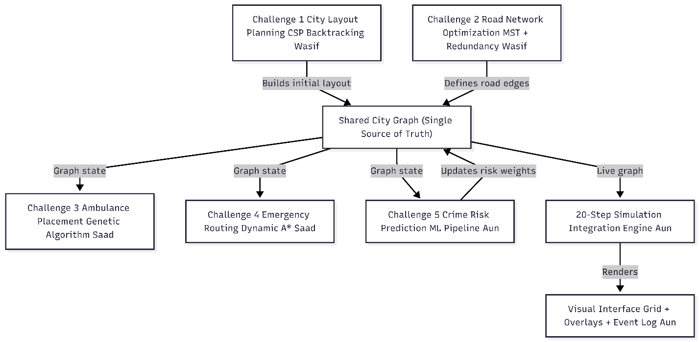

Graph Structure
The city is represented as a graph made up of nodes and edges.

Node Structure
Each node represents a specific location in the city and includes:
- Area type (Residential, Hospital, Industrial, School, Power Plant, Ambulance Depot)
- Population density
- Risk index (which changes over time)
- Accessibility status
- Geographic coordinates (grid position)

Edge Structure
Edges represent roads and include:
- Travel cost (default is 1.0)
- Terrain modifier (e.g., residential roads may have lower cost)
- Status (active or blocked)

If a road becomes blocked, it is immediately removed from all calculations in the system.

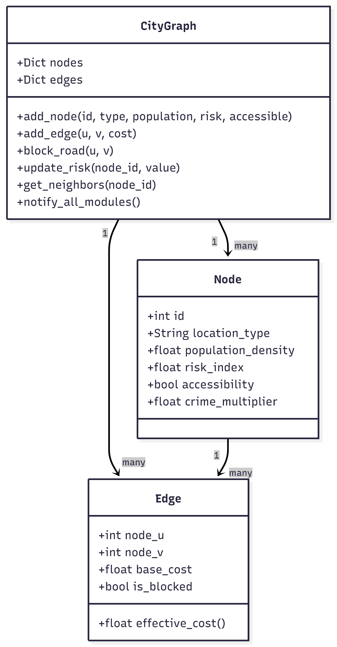

Challenge 1: City Layout Planning (CSP)
This part of the system focuses on assigning appropriate types to different areas of the city while following strict rules. It is modeled as a Constraint Satisfaction Problem (CSP).

Constraints
- Industrial areas cannot be placed next to hospitals or schools
- Residential areas must be within three hops of a hospital
- Power plants must be within two hops of industrial zones

Approach
A backtracking CSP solver is used, supported by:
- Minimum Remaining Values (MRV)
- Forward checking
- Constraint propagation

Why CSP?
Because it is well-suited for problems that involve many strict constraints within a large search space.

Comparison with Alternative
We also considered using a Greedy Search approach, where locations would be assigned one by one based on what seems best at each step. It's simpler and faster to implement, but the main issue is it cant backtrack. Once it makes a wrong assignment, it gets stuck. For a problem with this many interdependent constraints, greedy search would fail to find a valid layout in many cases. CSP with backtracking is guranteed to find a solution if one exists, which is why we chose it over greedy.

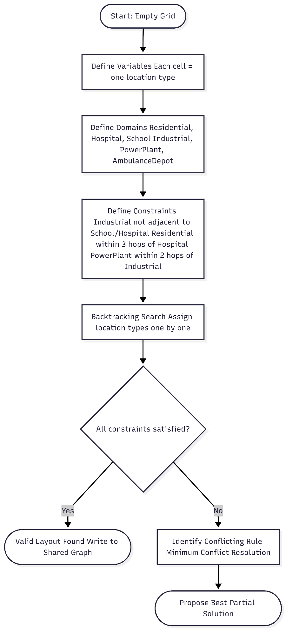

Challenge 2: Road Network Optimization
Once the city layout is defined, the system builds an efficient road network.

Objectives
- Minimize total road cost using a Minimum Spanning Tree
- Ensure redundancy between critical locations by having multiple paths

Approach
- Use Prim’s or Kruskal’s algorithm to build the base network
- Add extra connections to ensure reliability

Why this approach?
It provides a balance between cost efficiency and system reliability.

Comparison with Alternative
We thought about using a Genetic Algorithm for this challenge since it handles complex optimization well. But the thing is, for finding a minimum spanning tree, MST algorithms like Kruskal's already give you the exact optimal answer. A GA would give a near-optimal answer at best, and it would take more time and tuning. Since we need the globally optimal road network, not just a good one, MST was the better choice here.

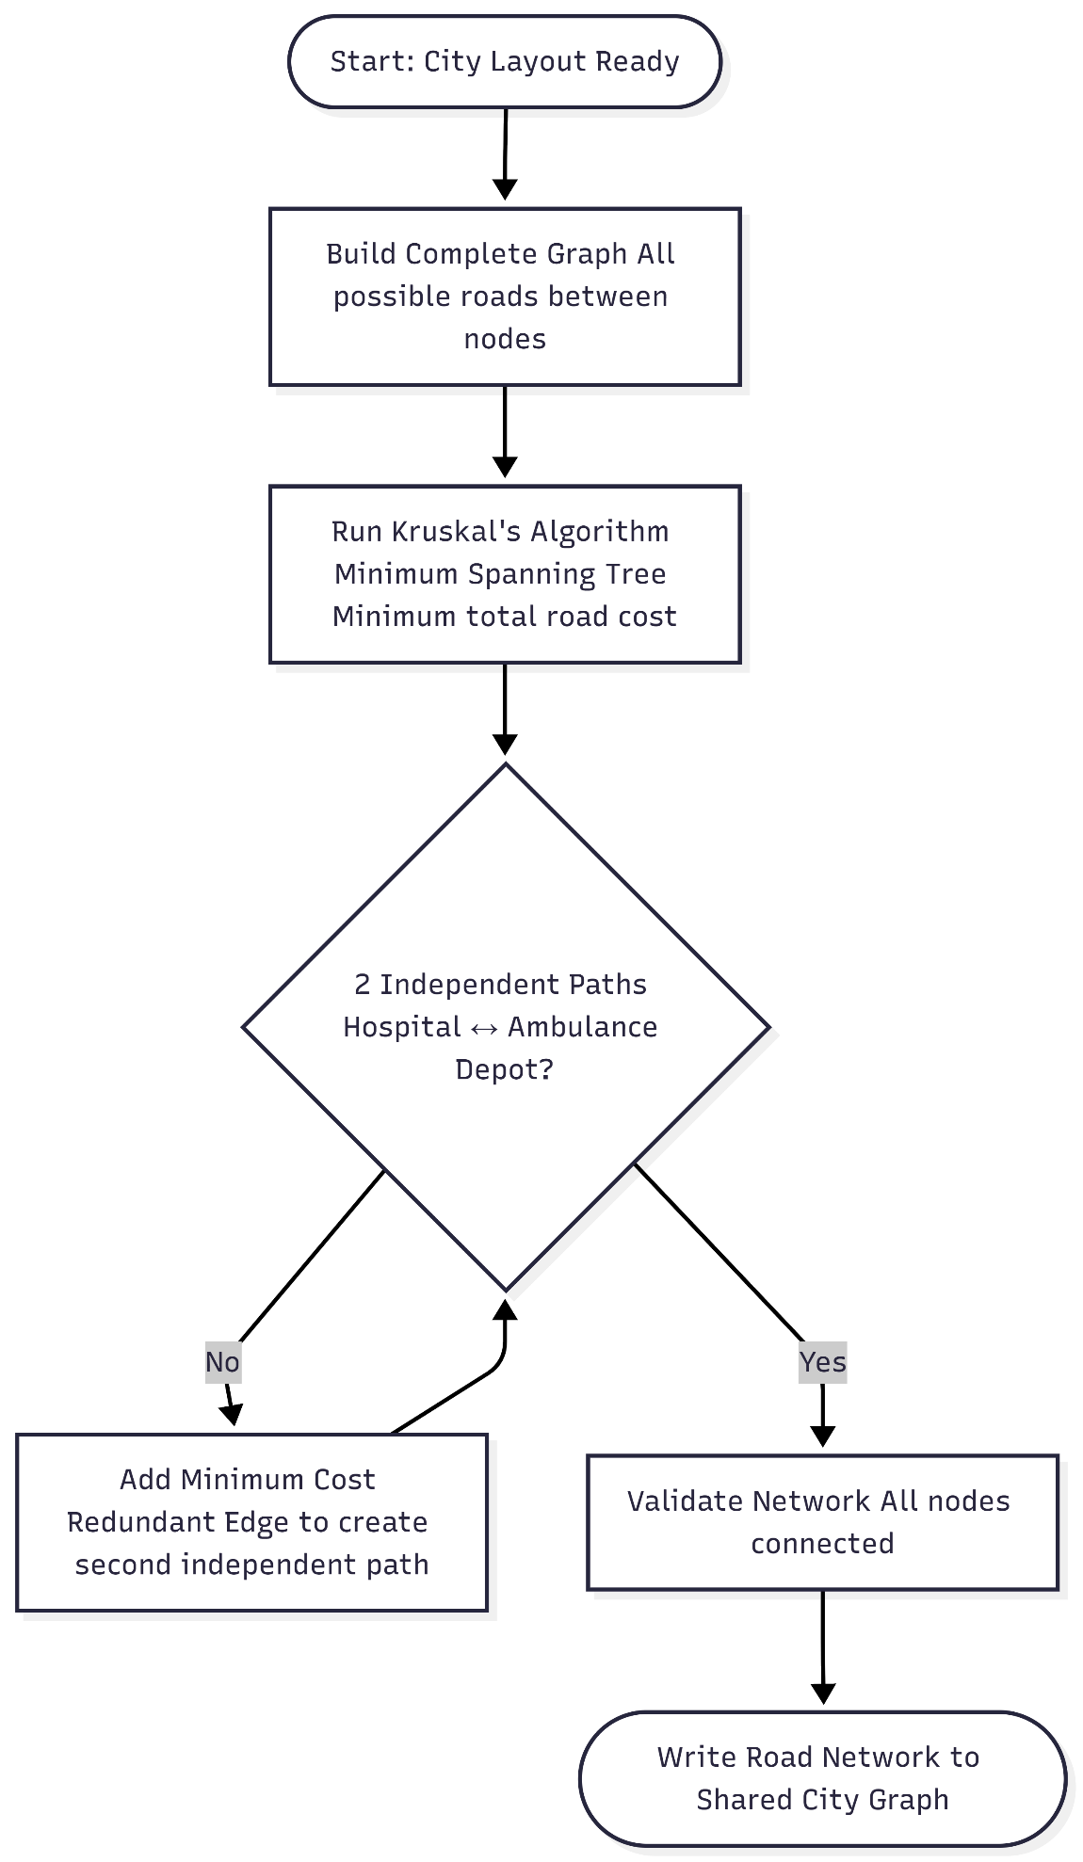

Challenge 3: Ambulance Placement Optimization
This module determines the best locations for ambulances to ensure quick response times.

Objective
Minimize the maximum distance between any citizen and the nearest ambulance.

Approach
- Use a Genetic Algorithm
- Evaluate solutions using a fitness function based on worst-case response time

Why GA?
Because the problem has a large and complex search space where traditional methods are not efficient.

Comparison with Alternative
Hill Climbing was the other option we looked at. It starts with a random placement and moves ambulances one at a time to improve the score. The problem is it easily get stuck in local optima, meaning it might settle on a placement that looks good locally but isn't actually the best. Since ambulance placement is critical, we didnt want to risk a suboptimal result. GA handles this better through mutation and crossover, so it was the right pick.

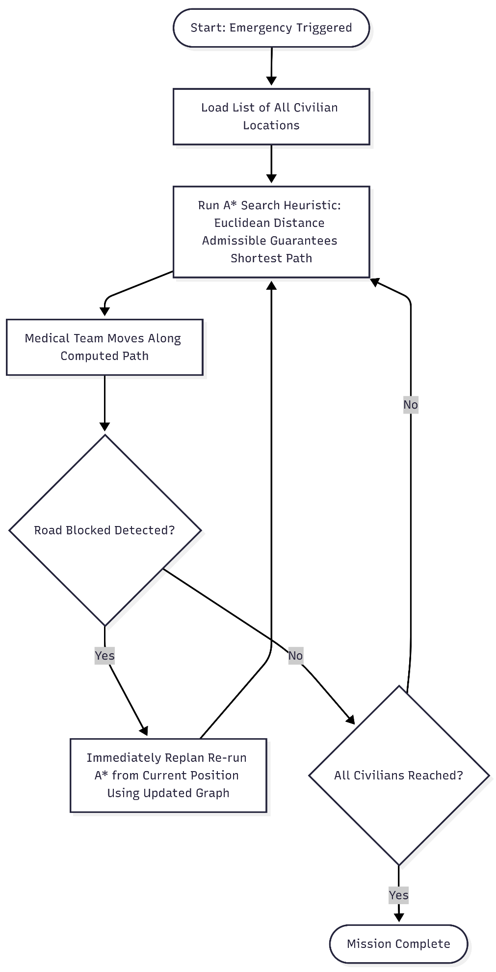

Challenge 4: Emergency Routing
This module handles routing in real time, especially when roads become unavailable.

Approach
- Use the A* search algorithm
- Apply a heuristic based on estimated shortest distance
- Recalculate routes when changes occur

Why A*?
It ensures optimal routing while adapting quickly to changes in the environment.

Comparison with Alternative
We considered Dijkstra’s algorithm (basically UCS) as the alternative. It also guarantees the shortest path but explores nodes in all directions without any guidance. A* uses a heuristic (Manhattan distance in our case) to focus the search toward the goal, making it faster. Both give the correct answer, but A* gets there quicker which matters alot when roads are changing in real time and we need to recalculate fast.



Challenge 5: Crime Risk Prediction (ML Pipeline)
This module adds machine learning capabilities to the system.

Step 1: Clustering
- Use K-Means to group areas based on population density and proximity to industrial zones

Step 2: Risk Prediction
- Train a classifier on synthetic data
- Classify areas as High, Medium, or Low risk

Integration
The predicted risk levels are used to adjust road weights in the graph.

Why ML?
It allows the system to make smarter decisions based on predicted patterns.

Comparison with Alternative (Clustering)
We looked at Hierarchical Clustering as an alternative to K-Means. Hierarchical doesn't require you to specify the number of clusters beforehand which is a nice property. However its computationaly expensive and doesn't scale well for a dynamic system where neighborhoods need to be quickly reassigned as the simulation progresses. K-Means is faster and works well when we already have an idea of how many risk zones we want, so we went with that.

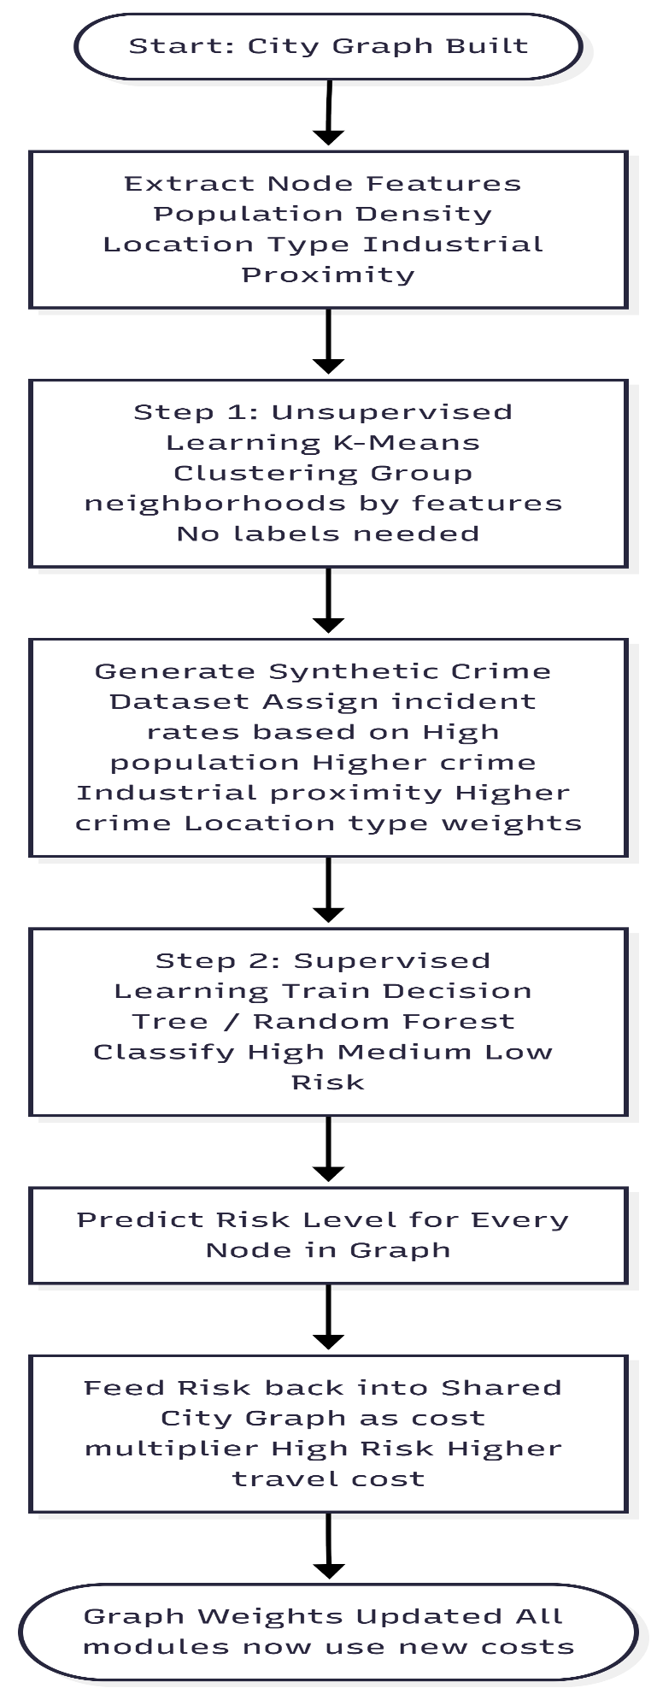

System Integration & Simulation
All modules work together in a 20-step simulation loop.

Simulation Flow
- Generate city layout using CSP
- Build and optimize the road network
- Assign crime risk using ML
- Optimize ambulance placement
- Perform emergency routing
- Simulate events like flooding

This creates a system that continuously adapts to changing conditions.

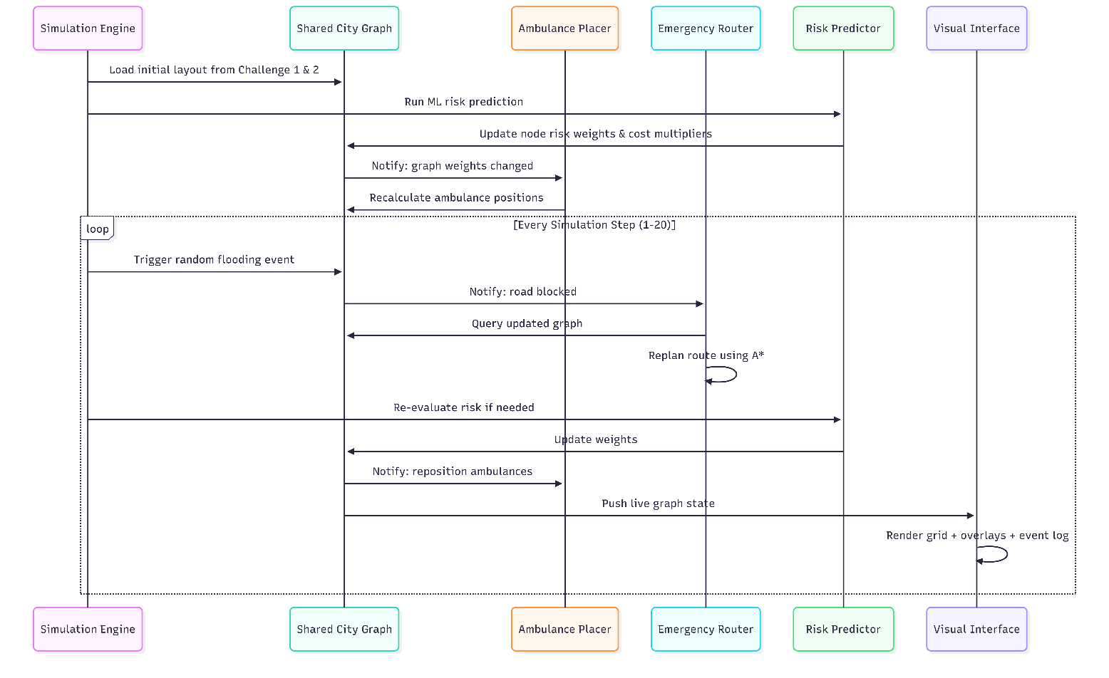

Algorithm Selection
Each algorithm was chosen based on the type of problem it solves:
- CSP → Handling constraints in layout design
- MST → Building cost-efficient networks
- Genetic Algorithm → Solving large optimization problems
- A* → Real-time pathfinding
- K-Means + Classification → Pattern detection and prediction

Other methods were considered but not used due to limitations in performance or scalability.

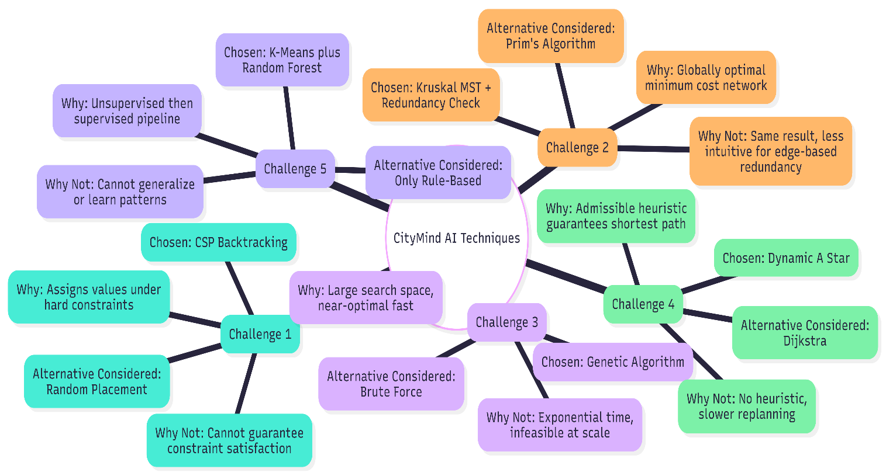

User Interface
The system includes an interface that displays:
- City layout
- Road network
- Ambulance coverage areas
- Crime risk heatmap
- Event logs (e.g., flooding, rerouting)

This helps users monitor the system and understand its behavior in real time.

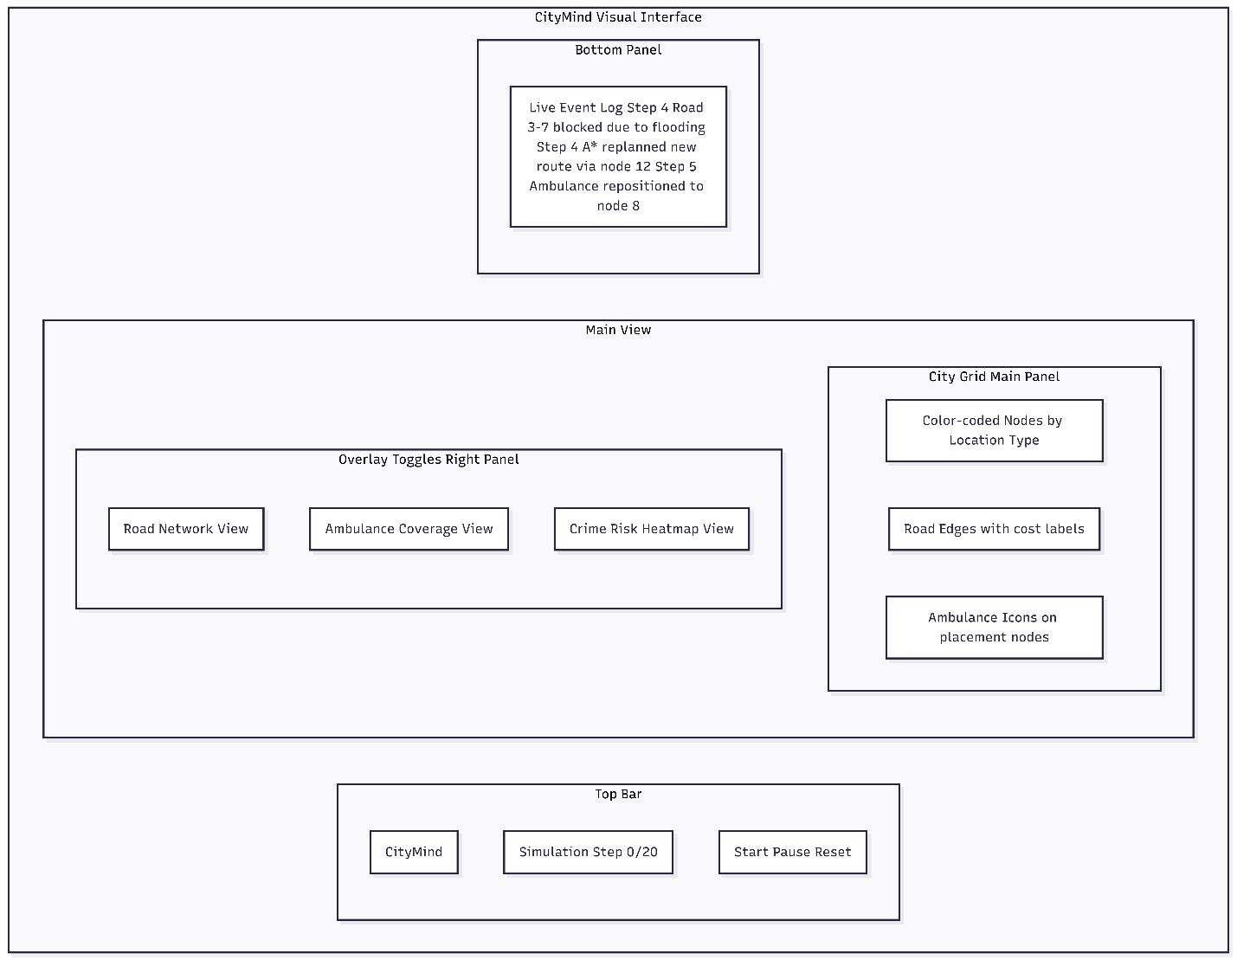

Conclusion
CityMind combines multiple AI techniques such as search, optimization, constraint solving, and machine learning into a single unified system. By operating on a shared, dynamic graph, it shows how different AI approaches can work together to improve decision-making in urban environments.

Implementation Approach Comparison

Python-Only Approach

Advantages
- Faster development
- Simpler architecture
- Easy integration with AI/ML tools
- Easier debugging and explanation
- No communication overhead
- Strong ecosystem

Limitations
- Slower performance for large-scale problems
- Not ideal for highly performance-critical systems
- May struggle with very large simulations

Hybrid Python + C++ Approach

Advantages
- Higher performance
- Better handling of heavy computations
- Improved scalability
- Suitable for real-time optimization

Limitations
- More complex architecture
- Requires communication between languages
- Harder to debug
- Longer development time
- More difficult to explain if not well designed

Final Decision Strategy
The system will initially be developed using Python due to its simplicity and flexibility. However, the design allows for future integration with C++ if performance improvements are needed.
This approach balances development speed, performance, ease of explanation, and future scalability.

Work Division
The work was split between all three members based on the challenges. Everyone was part of the initial design discussion before responsibilities were divided.

Member | Responsibilities | Challenges Covered
Aon Mohammad | City Layout Planner (CSP), shared city graph design, system integration | Challenge 1 + Core Architecture
Saad Ahmed | Road Network Optimization (MST), Ambulance Placement (GA), simulation loop | Challenge 2 + Challenge 3
Wasif Mughal | Emergency Routing (A*), Crime Risk ML pipeline, UI design and event logging | Challenge 4 + Challenge 5 + UI

